Form-Based Authentication
The auth-method element in the login-config element allows you to specify FORM as its value.
Assigning FORM as the value of auth-method means that you don't want to use the browser's standard Login page. Instead, you are telling the web container that you want to use your own
custom page. This is called form-based authentication.
You need to prepare two pages if you decide to use form-based authentication: a Login page and an Error page. The Login page, which can be a static file or a dynamic resource, is a page that is displayed when a user tries to access a restricted resource. Basically, the Login page can be as simple or as complex as you like. The requirements are that the Login page needs to contain an
HTML form with the following requisites:
• The method of the form must be POST.
• The value of the ACTION attribute must be "j_security_check".
• The form must have two input elements called j_username and j_password. Into these
elements the user enters the user name and password.
In addition, you need an Error page that can also be a static page or a dynamic resource. This page
is displayed when the user does not log in successfully. Note that the web container will display
the Error page on the first failed attempt to login.
The following is an example of form-based authentication. The deployment descriptor is given in
Listing 14.6.
Listing 14.6 The Deployment Descriptor for Form-Based Authentication
<?xml version="1.0" encoding="ISO-8859-1"?>
<!DOCTYPE web-app
PUBLIC "-//Sun Microsystems, Inc.//DTD Web Application 2.3//EN"
"http://java.sun.com/j2ee/dtds/web-app_2_3.dtd">
<web-app>
<security-constraint>
<web-resource-collection>
<web-resource-name>
Restricted Area
</web-resource-name>
<url-pattern>/servlet/*</url-pattern>
</web-resource-collection>
<auth-constraint>
<role-name>manager</role-name>
<role-name>tomcat</role-name>
</auth-constraint>
</security-constraint>
<login-config>
<auth-method>FORM</auth-method>
<form-login-config>
<form-login-page>/Login.html</form-login-page>
<form-error-page>/Error.html</form-error-page>
</form-login-config>
</login-config>
</web-app>
The form-login-config element specifies the URL of the Login page and the Error page. The
deployment descriptor mandates that the Login page is called Login.html and is to be found under
the application directory. The descriptor also tells the web container that the Error page for this
form-based authentication is named Error.html and is also found under the application directory.
Listings 14.7 and 14.8 list the Login page and the Error page, respectively.

Listing 14.7 Login.html
<HTML>
<HEAD>
<TITLE>Login Page</TITLE>
</HEAD>
<BODY>
<CENTER>
<H2>Please enter your user name and password</H2>
<FORM ACTION="j_security_check" METHOD="POST">
<TABLE>
<TR>
<TD>User name:</TD>
<TD><INPUT TYPE=TEXT NAME="j_username"></TD>
</TR>
<TR>
<TD>Password:</TD>
<TD><INPUT TYPE=PASSWORD NAME="j_password"></TD>
</TR>
<TR>
<TD><INPUT TYPE=RESET></TD>
<TD><INPUT TYPE=SUBMIT VALUE="Login"></TD>
</TR>
</TABLE>
</FORM>
</BODY>
</HTML>
Listing 14.8 Error.html
<HTML>
<HEAD>
<TITLE>Error Page</TITLE>
</HEAD>
<BODY>
Login failed. Click <A HREF="Login.html">here</A> to try again.
</BODY>
</HTML>

When a user tries to access the resource whose URL matches the pattern specified in the
deployment descriptor, the browser displays the Login page shown in Figure 14.5.

Figure 14.5. Login page.

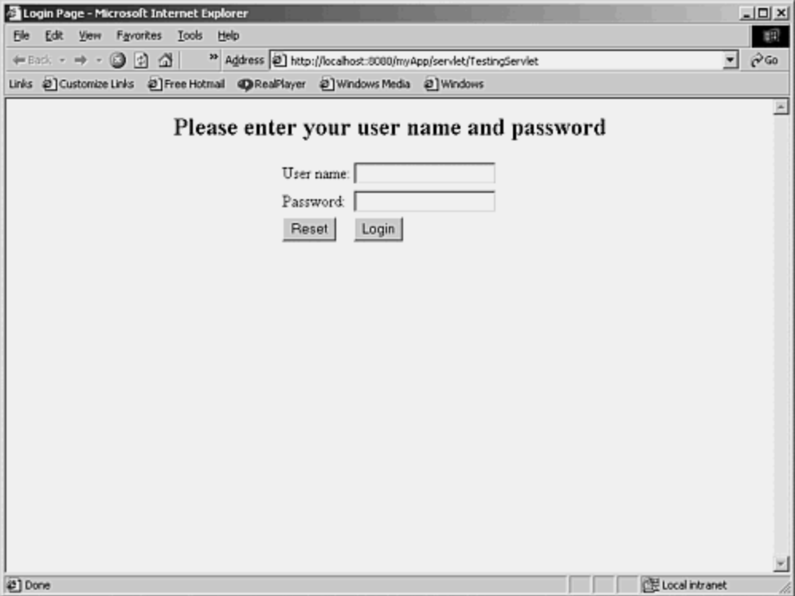

If the login fails, the Error page is displayed, as shown in Figure 14.6.

Figure 14.6. Error page.
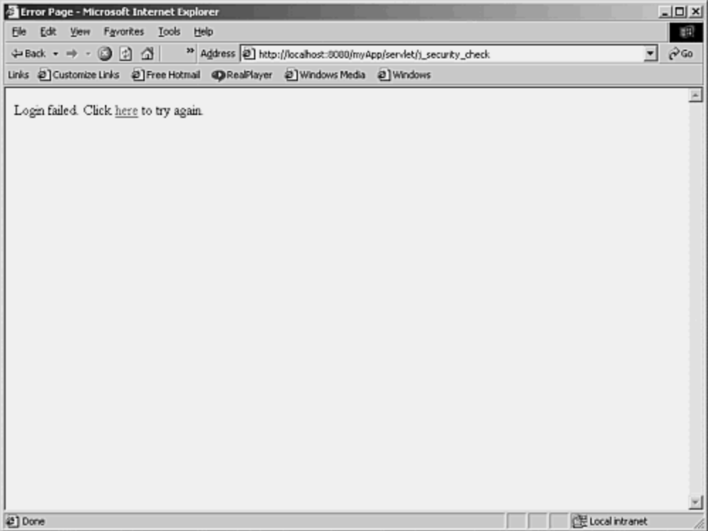
A successful login will display the requested page.

